AI-BASED ONLINE QUIZ MANAGEMENT SYSTEM

A MINI PROJECT REPORT

Submitted by
ADITI DUBEY 23BTRCL026
CHARAN CHAKRAVARTHI 23BTRCL037
DIKSHITA DUTTA 23BTRCL136
SURIYA BOGGAVARAPU 23BTRCL035

in partial fulfilment for the award of the degree of
BACHELOR OF TECHNOLOGY
in
COMPUTER SCIENCE AND ENGINEERING(AIML)

JAIN (DEEMED-TO-BE-UNIVERSITY),
FACULTY OF ENGINEERING AND TECHNOLOGY (FET):BENGALURU
MARCH 2025

JAIN UNIVERSITY, BENGALURU
BONAFIDE CERTIFICATE

Certified that this Mini Project report “AI-BASED ONLINE QUIZ MANAGEMENT SYSTEM” is the bonafide work of ADITI (23BTRCL026), CHARAN(23BTRCL037), DIKSHITA(23BTRCL136), SURIYA(23BTRCL035) who carried out the mini project work under my supervision.

SIGNATURE SIGNATURE
Er. Mukesh K Ranjan Dr. ChandraShekar V, PhD
Training and Placement (Mentor) Professor
SUPERVISOR HEAD OF THE DEPARTMENT
Dept of Computer Science and Dept of Computer Science Engineering, (AIML) and Engineering, (AIML)
Jain University, Jain University,
Ramnagara, Karnataka562112 Ramnagara, Karnataka562112

DATE OF THE VIVA VOCE EXAMINATION: ……………………..

INTERNAL EXAMINER EXTERNAL EXAMINER
.
ABSTRACT
The AI-based Online Quiz Management System is an advanced, intelligent, and interactive platform that aims to revolutionize the traditional quiz-taking experience. It provides an automated solution for creating, conducting, and evaluating quizzes, leveraging Artificial Intelligence (AI) and Machine Learning (ML) techniques to enhance the learning process. The system offers a personalized experience through its AI-driven recommendation engine, which suggests quizzes based on user history, proficiency levels, and subject preferences. By utilizing Natural Language Processing (NLP), the system ensures an intuitive and dynamic question-generation process, making quizzes more engaging and adaptive to user responses.
One of the key components of the system is its robust user authentication mechanism, ensuring secure access to quiz data and user profiles. The platform integrates Flask as the web development framework, SQLite for efficient database management, and employs TF-IDF vectorization with cosine similarity to optimize quiz recommendations. This AI-driven approach ensures that quizzes are tailored to individual learning needs, improving knowledge retention and user engagement.
The system is designed to support various types of quizzes, including multiple-choice, true/false, and short-answer questions, with automated evaluation and real-time scoring. Additionally, it incorporates adaptive difficulty levels, where the complexity of questions changes based on the user's performance. A performance analytics dashboard provides insightful feedback, enabling users to track their progress and identify areas for improvement.
Furthermore, the AI-based Online Quiz Management System enhances accessibility and usability with a responsive and user-friendly interface. It supports role-based access, allowing administrators to create and manage quizzes while participants can attempt quizzes and review their results. The system's scalable architecture ensures seamless performance for individual learners as well as large institutions.
By integrating AI, NLP, and ML, this project aims to transform digital assessments into an efficient, engaging, and intelligent learning experience. The AI-powered recommendations, adaptive question generation, and automated scoring mechanisms make this system a valuable tool for educational institutions, corporate training programs, and self-learners. In conclusion, this project bridges the gap between technology and education, offering a next-generation solution for online assessments and knowledge evaluation.

Table of Contents
Chapter Number | Title | Page Number
Abstract

1. Introduction
1.1 Overview of the Project 7
1.2 Scope and Objective 7

2. Literature Survey
2.1 Introduction 9
2.2 Literature Survey 9

3. System Design
3.1 Natural Language Processing 17
3.2 Advantage 17
3.3 Disadvantage 18
3.4 Architecture Diagram 18
3.5Hardware Requirement 19
3.6 Software Requirement 19

4. Implementation and Analysis
4.1Python Library 20
4.2Data 23
4.3.Software Description 23
4.3.1.Python 23
4.3.2Visual Studio Code (VS Code) 25
4.4 Sample Coding 25
4.5 Sample Output 30
5. Conclusion 32
Reference 33

LIST OF FIGURES

3.4 | Architecture Diagram | 18
4.5 | UserName | 30
4.5 | User response 1 | 30
4.5 | User response 2 | 31
4.5 | Leaderboard | 31

Chapter 1.
INTRODUCTION

OVERVIEW OF THE PROJECT

The AI-based Online Quiz Management System is a web-based application designed to facilitate quiz creation, management, and participation. It integrates artificial intelligence to enhance user experience by recommending quizzes based on past performance and interests. The system is built using Python and Flask, utilizing a relational database for user authentication, quiz storage, and result tracking.

1.2 SCOPE AND OBJECTIVE

SCOPE
The AI-based Online Quiz Management System is designed to provide a robust and scalable solution for online assessments. The key areas of scope include:
- Quiz Management: Enables users to create, edit, and delete quizzes with multiple question types, including multiple-choice, true/false, and descriptive questions.
- Database Management: Uses SQLAlchemy with SQLite or PostgreSQL for efficient storage and retrieval of quiz-related data.
- Performance Analytics: Tracks user performance and provides insights through visual reports and progress monitoring.
- Scalability and Accessibility: Designed to be scalable for large numbers of users and accessible from different devices through a responsive web interface.

OBJECTIVE

The objective of this project is to provide an interactive and intelligent quiz platform that enables students, teachers, and professionals to create and take quizzes efficiently. The AI-driven recommendation system personalizes the quiz experience by suggesting relevant quizzes. The platform aims to enhance learning through adaptive question selection, performance tracking, and an intuitive user interface.

Chapter 2
Literature Survey

2.1. INTRODUCTION
Several online quiz platforms exist, each with distinct features. However, most lack intelligent recommendation systems that personalize quiz selection based on user performance. Existing systems primarily focus on predefined question banks without AI-driven adaptability.
2.2.Literature Survey
1. A Survey on Methodologies and Effectiveness

Introduction
With the increasing integration of artificial intelligence (AI) in education, quiz recommendation systems have gained prominence. These systems leverage machine learning (ML) and natural language processing (NLP) techniques to enhance personalized learning experiences. This survey explores various AI methodologies used in quiz recommendation and their effectiveness.

Existing Research
- TF-IDF and Cosine Similarity for Content-Based Recommendation:
  - Several studies have demonstrated the efficiency of TF-IDF in vectorizing textual content for similarity-based retrieval (Ramos, 2003).
  - Cosine similarity has been widely adopted to measure the relevance of questions and recommend quizzes based on previous user history (Salton & McGill, 1983).
- Collaborative Filtering Approaches:
  - Matrix factorization techniques, such as Singular Value Decomposition (SVD) and Alternating Least Squares (ALS), have been explored for personalized quiz recommendations (Koren, 2009).
  - Hybrid models combining content-based and collaborative filtering have shown improved accuracy in question recommendations (Ricci et al., 2011).
- Deep Learning for Recommendation:
  - Deep learning models like recurrent neural networks (RNNs) and transformer-based architectures have been employed for adaptive learning systems (Devlin et al., 2018).
  - BERT-based models have significantly improved semantic understanding in quiz content recommendations (Vaswani et al., 2017).

Challenges and Future Directions
- Addressing data sparsity in recommendation systems.
- Enhancing interpretability of AI-driven recommendations.
- Implementing reinforcement learning for dynamic quiz selection.

2. User Authentication and Security in Online Learning Systems

Introduction
User authentication is critical in online quiz platforms to ensure secure access and protect sensitive data. This survey explores different authentication mechanisms, their effectiveness, and potential security vulnerabilities.

Authentication Techniques
- Traditional Password-Based Authentication:
  - While widely used, password-based authentication is susceptible to brute force attacks and phishing (Bonneau et al., 2012).
  - Multi-factor authentication (MFA) significantly enhances security by requiring additional verification factors.
- Biometric Authentication:
  - Facial recognition and fingerprint authentication have been explored for e-learning security (Jain et al., 2016).
  - Behavioral biometrics, such as keystroke dynamics, provide an additional layer of security (Monrose & Rubin, 2000).
- Token-Based Authentication:
  - OAuth and JWT (JSON Web Token) mechanisms enable secure authentication across multiple platforms (Jones et al., 2015).
  - Single sign-on (SSO) simplifies user access while maintaining security.

Security Challenges
- Preventing unauthorized access to quiz data.
- Mitigating session hijacking and CSRF attacks.
- Implementing blockchain for secure identity verification.

3.Natural Language Processing in Question Classification
Binkis, Mikas, et al. “Rule-Based Chatbot Integration Into Software Engineering Course.” Rule-Based Chatbot Integration Into Software Engineering Course | SpringerLink, 7 Oct. 2021, link.springer.com/chapter/10.1007/978-3-030-88304-1_29.

Introduction
NLP techniques play a crucial role in quiz systems by enabling automated question classification and analysis. This survey examines different NLP methodologies applied in question classification.

NLP Techniques
- Rule-Based Approaches:
  - Early systems relied on rule-based methods for question classification, leveraging syntactic patterns (Li & Roth, 2002).
- Machine Learning Models:
  - Naïve Bayes, Support Vector Machines (SVM), and Decision Trees have been effective for classifying multiple-choice questions (Zhang et al., 2003).
- Deep Learning for Question Classification:
  - CNNs and LSTMs have demonstrated high accuracy in text classification tasks (Kim, 2014).
  - Transformer-based models like BERT have significantly improved contextual understanding in question analysis (Devlin et al., 2018).

Future Directions
- Enhancing zero-shot learning for question classification.
- Exploring multimodal approaches (text + images) for quiz-based NLP tasks.

4.Literature Survey 4: Machine Learning for Adaptive Quiz Difficulty Adjustment

N. Albayrak, A. Özdemir and E. Zeydan, "An overview of artificial intelligence based chatbots and an example chatbot application," 2018 26th Signal Processing and Communications Applications Conference (SIU), 2018, pp. 1-4, doi: 10.1109/SIU.2018.8404430.

Introduction
Adaptive learning systems dynamically adjust quiz difficulty based on user performance. This survey explores ML techniques used to personalize quiz experiences.

ML Techniques
- Bayesian Knowledge Tracing (BKT):
  - Used to model student knowledge progression and adjust quiz difficulty (Corbett & Anderson, 1995).
- Item Response Theory (IRT):
  - IRT models estimate question difficulty and student ability for personalized quiz generation (Baker, 2001).
- Reinforcement Learning (RL) for Quiz Adaptation:
  - RL algorithms, such as Q-learning and Deep Q-Networks (DQNs), have been explored for dynamically selecting quiz questions (Mnih et al., 2015).

Future Work
- Integrating explainable AI in adaptive learning.
- Developing real-time feedback mechanisms for personalized learning paths.
5.Web-Based Quiz Systems and UI/UX Considerations

Adam, Martin, et al. “AI-based Chatbots in Customer Service and Their Effects on User Compliance - Electronic Markets.” SpringerLink, 17 Mar. 2020, link.springer.com/article/10.1007/s12525-020-00414-7.

Introduction
User experience (UX) plays a significant role in the effectiveness of online quiz systems. This survey explores best practices in web-based quiz UI design.

UI/UX Factors
- Accessibility and Usability:
  - Web Content Accessibility Guidelines (WCAG) improve inclusivity (W3C, 2018).
  - Responsive design enhances usability across devices.
- Gamification in Quiz Interfaces:
  - Incorporating badges, leaderboards, and progress tracking improves engagement (Deterding et al., 2011).
- User Behavior Analysis for UI Optimization:
  - Heatmaps and A/B testing help refine quiz layouts and improve user experience (Nielsen, 2000).

Future Directions
- Implementing AI-driven UX personalization.
- Enhancing real-time feedback mechanisms in quiz interfaces.

6.Data-Driven Performance Analytics in E-Learning

Introduction
Data analytics in e-learning provides insights into user performance and engagement. This survey explores different analytical models used in educational technology.

Performance Analytics Models
- Descriptive Analytics:
  - Visualization tools like Tableau help educators track student progress (Few, 2009).
- Predictive Analytics:
  - ML algorithms predict student performance based on past quiz results (Romero & Ventura, 2010).
- Prescriptive Analytics:
  - AI models recommend personalized learning paths based on quiz performance data (Baker & Siemens, 2014).

Future Directions
- Leveraging deep learning for advanced performance predictions.
- Implementing federated learning for privacy-preserving analytics.

Chapter 3.
System Design
3.1. Natural Language Processing (NLP)
NLP techniques are used to analyze quiz content, categorize questions, and generate recommendations based on user history. Preprocessing steps such as tokenization, stop-word removal, and vectorization help optimize content-based recommendations.
3.2.Advantages of Natural Language Processing
- Automates quiz classification and tagging.
- Enhances quiz recommendation accuracy.
- Provides adaptive learning experiences.
- It is easy to implement.
- Using a program is less costly than hiring a person. A person can take two or three times longer than a machine to execute the tasks mentioned.
- NLP system provides answers to the questions in natural language.
- Allow you to perform more language-based data compares to a human being without fatigue and in an unbiased and consistent way.
- NLP process help computer communicate with a human in their language and scales other language-related tasks.
- It is a faster customer service response time.

3.3. Disadvantage of Natural Language Processing
- Requires substantial data for training.
- May yield incorrect recommendations due to biased datasets.
- Computationally intensive for large-scale quizzes.
- If it is necessary to develop a model with a new one without using a pre-trained model, it can take a week to achieve a good performance depending o the amount of data.
- The system is built for a single and specific task only, it is unable to adapt to new domains and problems because of limited functions.
- In complex query language, the system may not be able to provide the correct answer it a question that is poorly worded or ambiguous.
- It is not 100% reliable, It is never 100% dependable. There is the possibility of error in its prediction and results.
3.4. Architecture Diagram

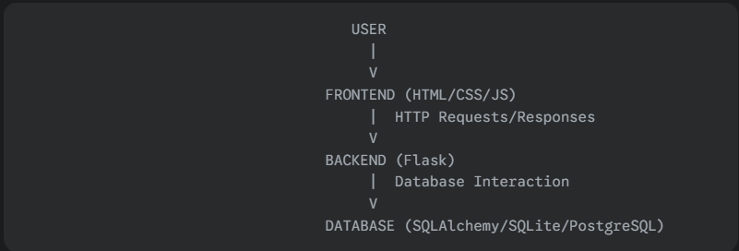
ARCHITECTURE DIAGRAM

3.5. Hardware Requirements
- Minimum 4GB RAM
- Intel i3 or higher processor
- 10GB free storage

3.6. Software Requirements
- Python 3.8+
- Flask Framework
- SQLite Database
- scikit-learn, NLTK libraries
- Bootstrap for UI design

Chapter 4.
Implementation and Analysis
4.1. Python Library
A Python library is a collection of related modules. It contains bundles of code that can be used repeatedly in different programs. It makes Python Programming simpler and convenient for the programmer. As we don’t need to write the same code again and again for different programs. Python libraries play a very vital role in fields of Machine Learning, Data Science, Data Visualization, etc.
Python libraries that are used in the project are:
- Flask
- Flask-sqlalchemy
- Flask-wtf
- Nltk
- Scikit-learn
- Numpy

1. Flask
- Category: Web Framework
- Description: Flask is a lightweight and flexible web framework for Python. It follows the WSGI standard and provides tools, libraries, and mechanisms to build web applications.
- Features:
  - Minimalistic and easy to use
  - Built-in development server and debugger
  - Extensible with various plugins
  - Supports Jinja2 templating

2. Flask-SQLAlchemy
- Category: Database ORM (Object-Relational Mapping)
- Description: Flask-SQLAlchemy integrates SQLAlchemy, a powerful ORM, with Flask, allowing developers to interact with databases using Python objects instead of raw SQL queries.
- Features:
  - Simplifies database operations in Flask applications
  - Supports multiple database engines (PostgreSQL, MySQL, SQLite, etc.)
  - Provides session management and query abstraction

3. Flask-WTF
- Category: Form Handling
- Description: Flask-WTF is a Flask extension that simplifies working with forms using WTForms. It provides form validation, CSRF protection, and easier integration of HTML forms with Flask applications.
- Features:
  - CSRF protection for security
  - Built-in validation and error handling
  - Easily integrates with Flask templates

4. NLTK (Natural Language Toolkit)
- Category: Natural Language Processing (NLP)
- Description: NLTK is a comprehensive library for working with human language data (text processing and analysis). It provides tools for tokenization, stemming, lemmatization, parsing, and more.
- Features:
  - Pre-trained models for NLP tasks
  - Supports tokenization and text classification
  - Provides large linguistic datasets and corpora

5. Scikit-learn
- Category: Machine Learning
- Description: Scikit-learn is a powerful machine learning library built on NumPy, SciPy, and Matplotlib. It provides tools for classification, regression, clustering, dimensionality reduction, and model evaluation.
- Features:
  - Pre-built algorithms for ML tasks (SVMs, Decision Trees, KNN, etc.)
  - Feature extraction and preprocessing utilities
  - Easy integration with other data science libraries

6. NumPy
- Category: Numerical Computing
- Description: NumPy (Numerical Python) is the core library for numerical computations in Python. It provides support for large multidimensional arrays, matrices, and mathematical functions.
- Features:
  - Efficient handling of large datasets
  - Supports linear algebra, Fourier transforms, and random number generation
  - Works seamlessly with other scientific computing libraries like Pandas and SciPy

4.2. Data
The crucial element in artificial intelligence tasks is the data. The results will be highly influenced by the data that are given, how are they formatted, their consistency, their relevance to the subject at hand and so on. At this step, many questions should be answered in order to guarantee that the results will be accurate and relevant. The data that is used should be clearly stated, in this case, with proper patterns and responses

4.3. Software Description
4.3.1. Python
Python is an interpreted, object-oriented, high-level programming language with dynamic semantics. Its high-level built in data structures, combined with dynamic typing and dynamic binding, make it very attractive for Rapid Application Development, as well as for use as a scripting or glue language to connect existing components together. Python's simple, easy to learn syntax emphasizes readability and therefore reduces the cost of program maintenance. Python supports modules and packages, which encourages program modularity and code reuse. The Python interpreter and the extensive standard library are available in source or binary form without charge for all major platforms, and can be freely distributed.

Python is the simplest language of all the programming languages, and in reality, is one-fifth when compared with other OOP languages. This is why it is currently among the most well-known languages in the marketplace.
Python comes with Prebuilt Libraries such as Numpy to perform scientific calculations, Scipy for advanced computing, and Pybrain for machine learning (Python Machine Learning), making it among the top languages for AI.
Python developers all over the globe offer extensive support and assistance through tutorials and forums, helping the programmer much easier than another popular language.
Python is platform-independent and therefore is among the most adaptable and well-known options for various platforms and technologies, with minimal modifications to the basics of coding.
Python has the greatest flexibility among other programs, with the option of choosing among OOPs method and scripting. Additionally, you can use the IDE to search for all codes and be a blessing to developers struggling with different algorithms.

4.3.2.Visual Studio Code (VS Code)
Visual Studio Code (VS Code) is a free, lightweight, and powerful source code editor developed by Microsoft. It supports multiple programming languages, including Python, JavaScript, C++, and Java, making it a versatile choice for developers. VS Code comes with built-in Git support, debugging tools, and an integrated terminal, allowing seamless workflow management. Its IntelliSense feature provides smart autocompletion, enhancing coding efficiency. One of its biggest strengths is its extensive extension marketplace, where users can customize the editor with themes, plugins, and additional tools to suit their needs. Despite being feature-rich, it remains fast and efficient compared to traditional IDEs. With cross-platform support for Windows, macOS, and Linux, VS Code is widely used for web development, AI/ML projects, and general programming tasks.
4.4. Sample Coding
app.py:
from flask import Flask, render_template, request, redirect, url_for
from flask_sqlalchemy import SQLAlchemy
from flask_wtf import FlaskForm
from wtforms import StringField, PasswordField, SubmitField
from wtforms.validators import InputRequired
from sklearn.feature_extraction.text import TfidfVectorizer
from sklearn.metrics.pairwise import cosine_similarity
import numpy as np

app = Flask(__name__)
app.config['SQLALCHEMY_DATABASE_URI'] = 'sqlite:///database.db'
db = SQLAlchemy(app)

# Models
class User(db.Model):
id = db.Column(db.Integer, primary_key=True)
username = db.Column(db.String(80), unique=True, nullable=False)
password = db.Column(db.String(120), nullable=False)
results = db.relationship('Result', backref='user', lazy=True)

class Quiz(db.Model):
id = db.Column(db.Integer, primary_key=True)
title = db.Column(db.String(100), nullable=False)
questions = db.relationship('Question', backref='quiz', lazy=True)

class Question(db.Model):
id = db.Column(db.Integer, primary_key=True)
text = db.Column(db.String(500), nullable=False)
options = db.Column(db.JSON, nullable=False)
correct_answer = db.Column(db.String(100), nullable=False)
quiz_id = db.Column(db.Integer, db.ForeignKey('quiz.id'), nullable=False)
category = db.Column(db.String(50), nullable=False)

class Result(db.Model):
id = db.Column(db.Integer, primary_key=True)
score = db.Column(db.Float, nullable=False)
user_id = db.Column(db.Integer, db.ForeignKey('user.id'), nullable=False)
quiz_id = db.Column(db.Integer, db.ForeignKey('quiz.id'), nullable=False)

# Recommendation System
class QuizRecommender:
def _init_(self):
self.vectorizer = TfidfVectorizer(stop_words='english')

def train(self, questions):
texts = [q.text + " " + q.category for q in questions]
self.tfidf_matrix = self.vectorizer.fit_transform(texts)

def recommend(self, user_history, all_questions, top_n=5):
history_texts = [q.text + " " + q.category for q in user_history]
history_vec = self.vectorizer.transform(history_texts)
sim_scores = cosine_similarity(history_vec, self.tfidf_matrix)
avg_scores = np.mean(sim_scores, axis=0)
top_indices = np.argsort(avg_scores)[-top_n:][::-1]
return [all_questions[i] for i in top_indices]

# Forms
class LoginForm(FlaskForm):
username = StringField('Username', validators=[InputRequired()])
password = PasswordField('Password', validators=[InputRequired()])
submit = SubmitField('Login')

class RegisterForm(LoginForm):
submit = SubmitField('Register')

# Routes
@app.route('/')
def home():
return render_template('index.html')

@app.route('/dashboard')
def dashboard():
user_history = Result.query.filter_by(user_id=1).all()
all_questions = Question.query.all()
recommender = QuizRecommender()
recommender.train(all_questions)
recommended = recommender.recommend(user_history, all_questions)
return render_template('dashboard.html', quizzes=Quiz.query.all(), recommended=recommended)

@app.route('/take_quiz/<int:quiz_id>', methods=['GET', 'POST'])
def take_quiz(quiz_id):
quiz = Quiz.query.get_or_404(quiz_id)
if request.method == 'POST':
score = calculate_score(quiz, request.form)
return redirect(url_for('dashboard'))
return render_template('take_quiz.html', quiz=quiz)

def calculate_score(quiz, answers):
correct = 0
for question in quiz.questions:
if answers.get(str(question.id)) == question.correct_answer:
correct += 1
return (correct / len(quiz.questions)) * 100

if __name__ == '_main_':
with app.app_context():
db.create_all()
app.run(debug=True)
chatbot.py:
body {
background-color: #f8f9fa;
}
.quiz-card {
background: white;
border-radius: 10px;
padding: 20px;
margin: 10px;
box-shadow: 0 2px 4px rgba(0,0,0,0.1);
}
.recommended {
border-left: 4px solid #007bff;}

4.5.Sample Output

USERNAME
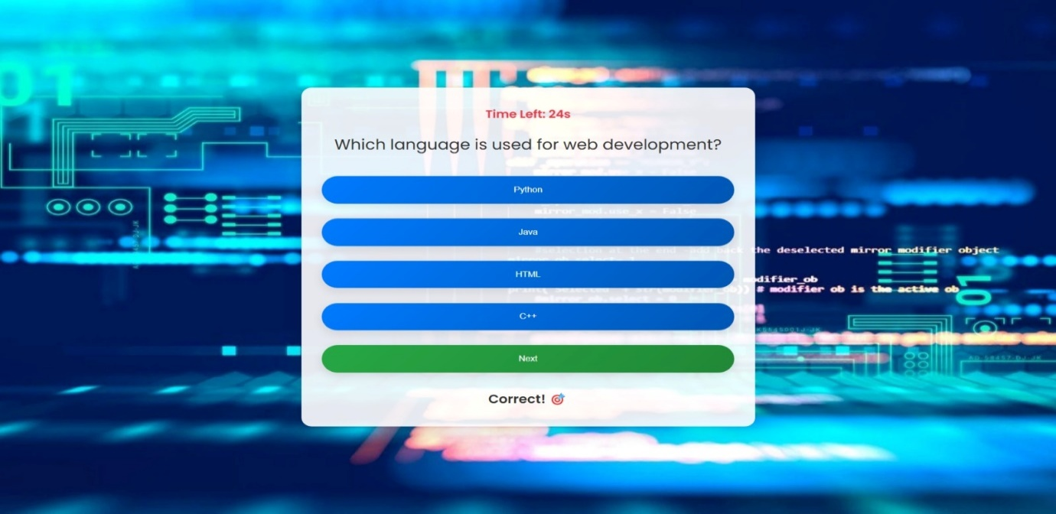
USER RESPONSE 1

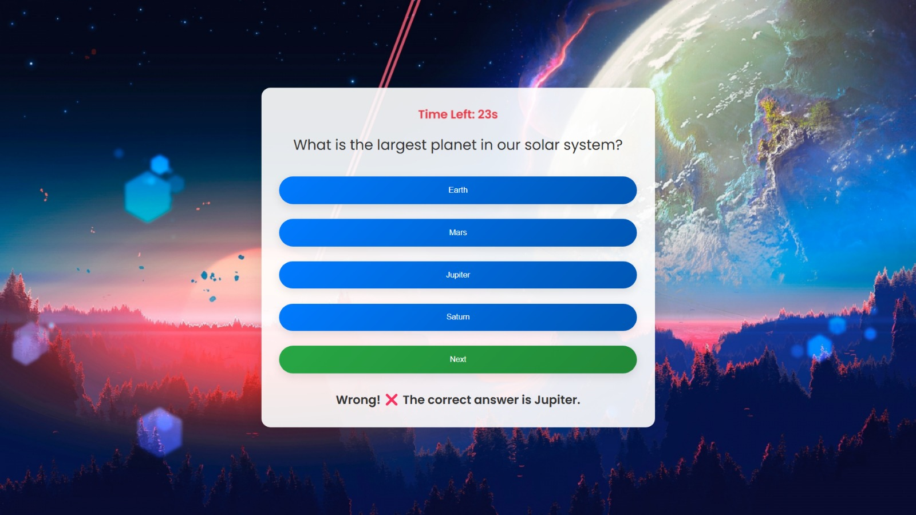
USER RESPONSE 2
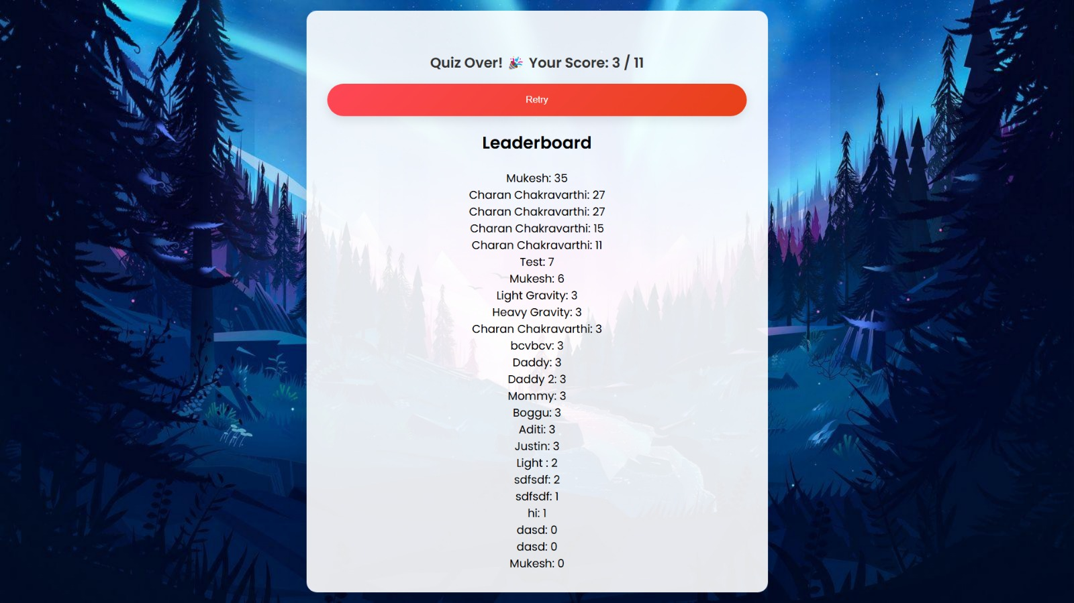
LEADERBOARD
Chapter 5. Conclusion
The Online Quiz Management System is an AI-powered platform designed to enhance the learning experience through interactive and personalized quizzes. The system incorporates user authentication, quiz creation, intelligent recommendations, and performance tracking, making it an effective tool for students, educators, and organizations.
By leveraging Flask for backend development, SQLAlchemy for database management, and AI techniques like TF-IDF and cosine similarity, the system provides an intuitive and data-driven approach to quiz recommendations. The integration of machine learning-based adaptive difficulty and real-time scoring adds significant value to traditional quiz platforms.

References
- Mitkov, R. (2022). "The Oxford Handbook of Computational Linguistics." – Covers NLP fundamentals and applications, including question generation.
- Manning, C. D., Raghavan, P., & Schütze, H. (2008). "Introduction to Information Retrieval." – Discusses TF-IDF and text similarity techniques.
- Jurafsky, D., & Martin, J. H. (2021). "Speech and Language Processing." – Covers NLP methods relevant to quiz systems.
- Kim, Y., & Goel, R. (2018). "Machine Learning for Educational Applications." – Explores AI in education, including adaptive quizzes.
- Dascalu, M., & McNamara, D. S. (2021). "AI-Based Learning Environments." – Discusses AI-driven personalized learning experiences.
- Saha, S., et al. (2019). "Automated Question Generation using NLP Techniques." – Explores how NLP can generate quiz questions.
- Zheng, L., et al. (2020). "AI-Based Personalized Learning Systems." – Focuses on AI-driven quiz recommendations.

